**Simultaneous equations: By elimination**

Simultaneous equations are two equations with two unknowns. They are called simultaneous because they must both be solved at the same time.

**Example 1**

**Step 1***Try to eliminate one of the unknowns.*

*Solve these simultaneous equations and find the values of* ***x*** *and* ***y****.*

2x + y = 7 (1)

3x - y = 8 (2)

**Step 2** *Add the two equations to eliminate the* ***y****s*:

2x + y = 7

3x - y = 8

------------

5x = 15 (divide by 5)

x = 3

**Step 3** *Now you can put x = 3 in either of the equations*.

Substitute x = 3 into the equation 2x + y = 7:

6 + y = 7 So y = 1

So the answers are **x = 3** and **y = 1**

**Example 2**

*Here one equation is altered to make one term in each equation the same(disregarding the +/- sign). These terms are then added or subtracted to eliminate them.*

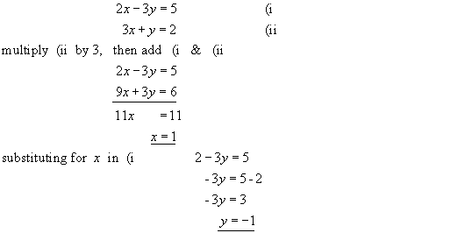

**Example 3**

Solve

5x + 3y = 1 (1)

3x - 2y = 12 (2)

**Step 1:** *Multiply equation (1) by 3 and then multiply equation (2) by 5.*

15x + 9y = 3 (3)

15x - 10y = 60 (4)

**Step 2:** *We can now subtract equation (4) from equation (3) to eliminate (x).*

9y - -10y= 3 -60

19 y = -57 (divide by 19)

Y = - 3

**Step 3** *Now substitute back into Equations 1 or Equation 2 to find x*

5x + 3 (-3) = 1

5x - 9 = 1

5x = 10

x = 2

**Step 4** *Check by substituting into equation 2*

3(2) – 2 (-3) =12

6 + 6 =12

12 = 12

So x = 2 and y = -3

Try these

1) 2*x* + 2*y* = 10 2) 3x + y =18 3) 4x + 3y = 11 4) 5*x* + 3*y* = 18

*x* + 2*y* = 6 2x + y =13 2x + y =7 5*x* + *y* = 16

5) 5*x* + 2*y* = 33 6) 6x + 2y = 10 7) 2x + 3y = 28 8) 5x + 3y = 14

2*x* + *y* = 14 4x + y =7 3x – y = 9 2x + 2y =4